**Data Analyst in Power BI Data-Camp 2025**

**Section 3: Data Visualization in Power BI**

1. **The Audience is King**

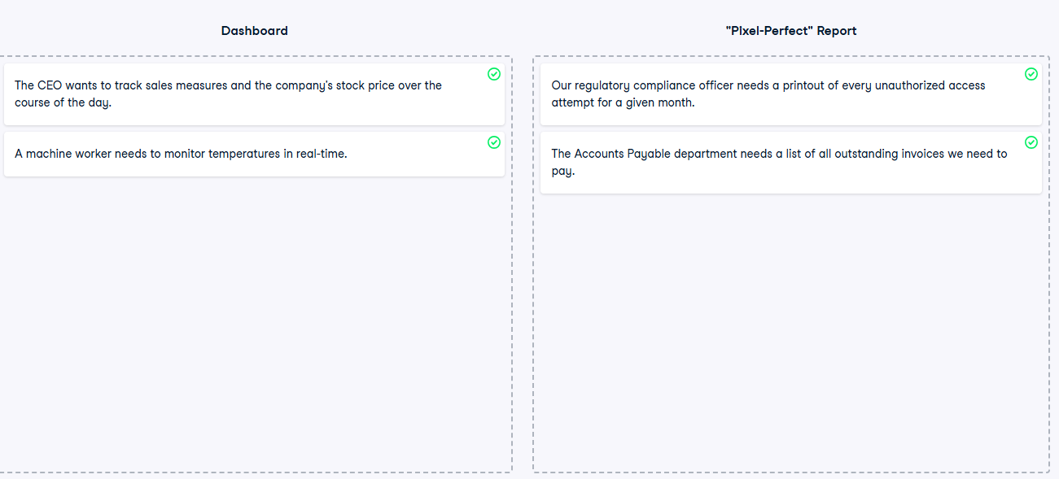

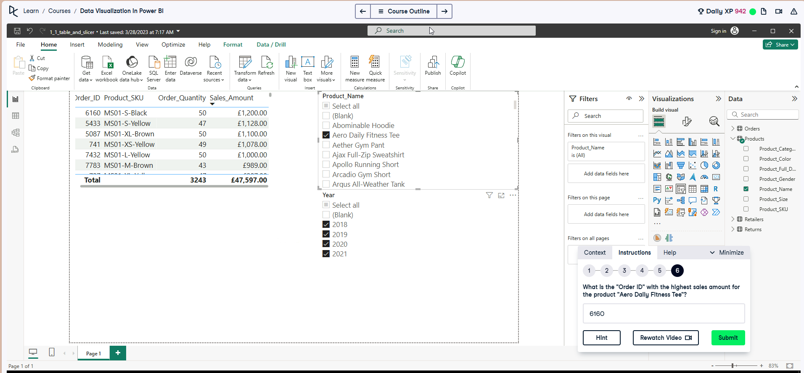**Exercise 1.1**

Order_Date we want OrderName selected not Date Hierarchy.

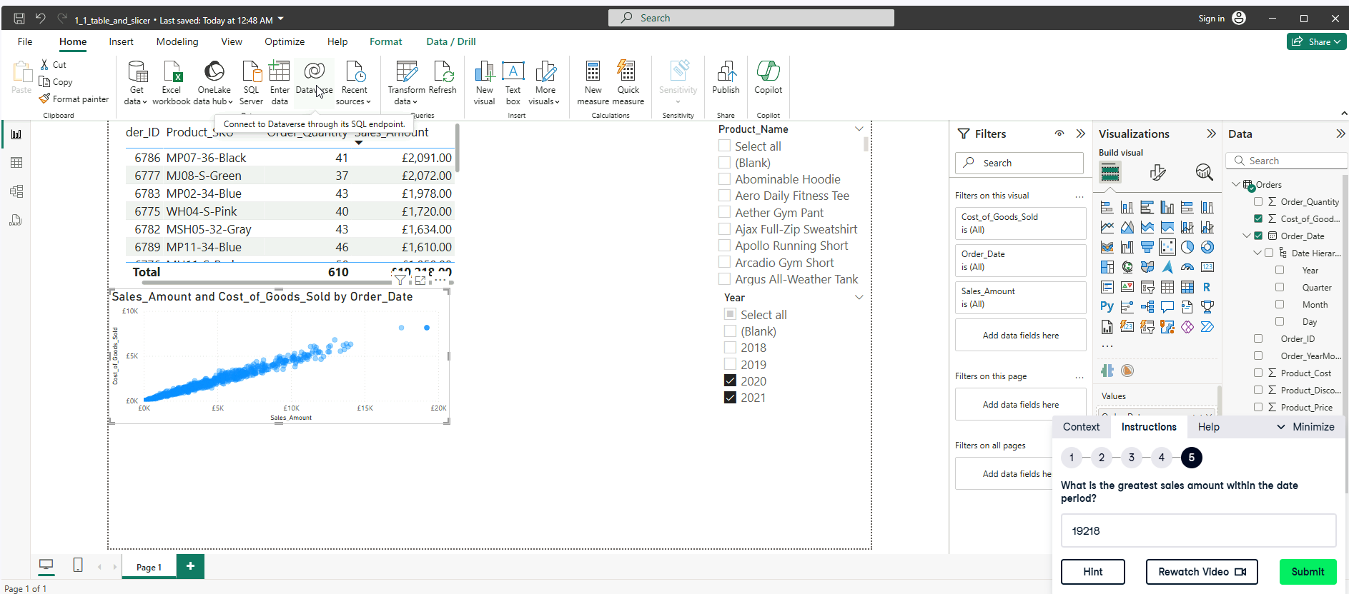

It is the last point on the far right.

**Exercise 1.3.** 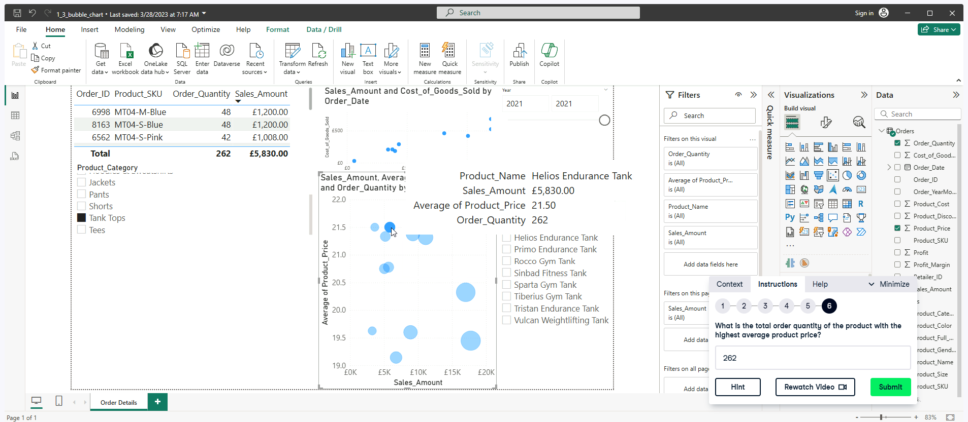

**

**

**Exercise 2.3**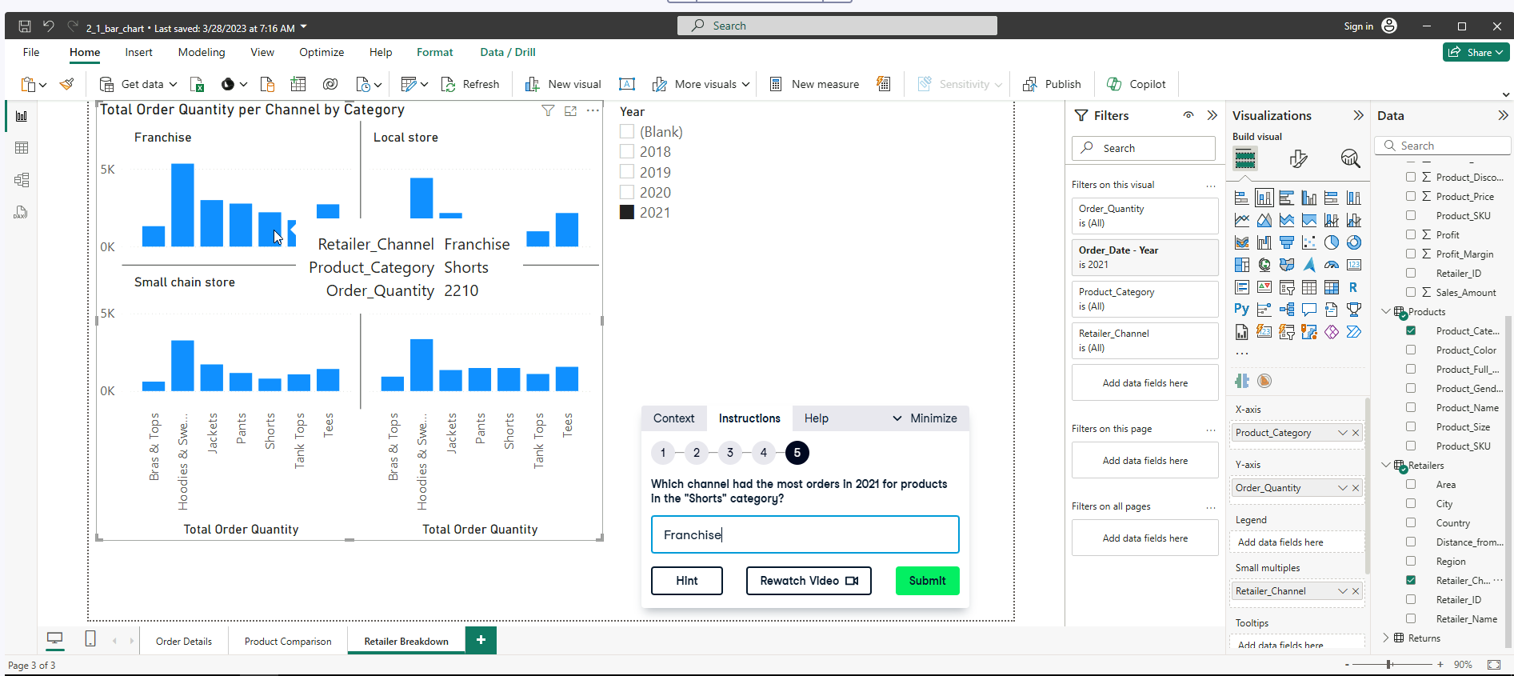

**Exercise 2.4**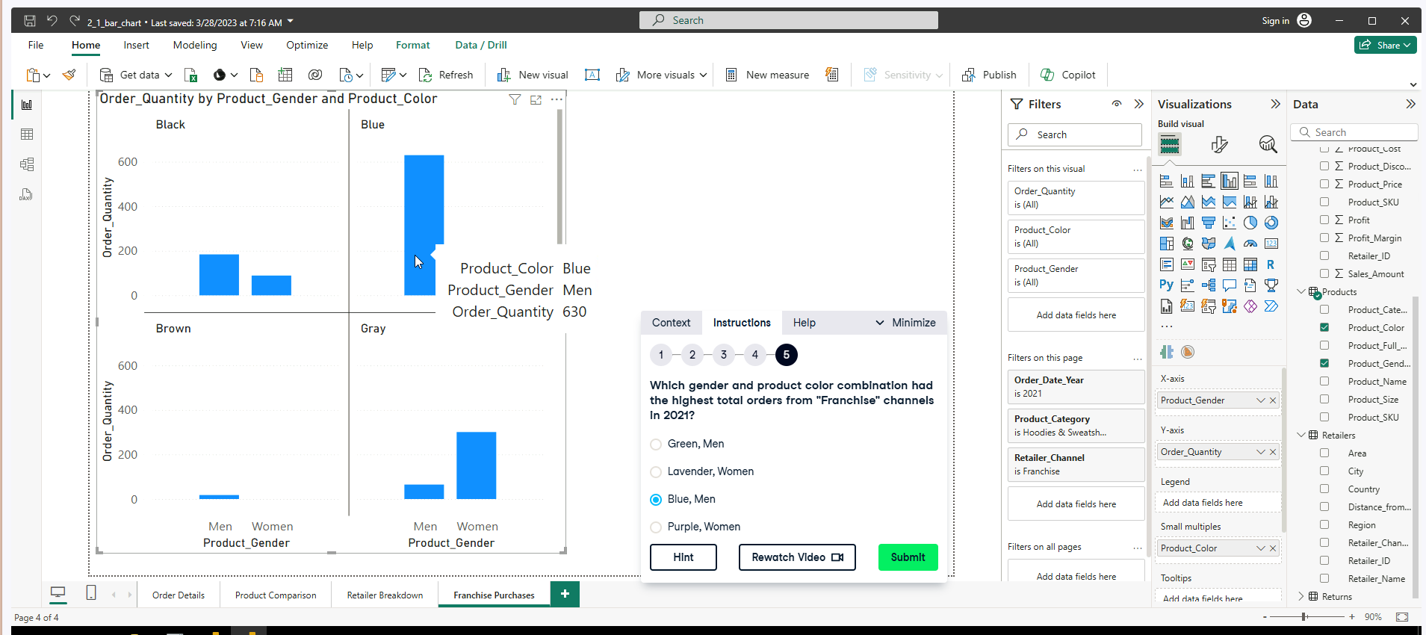

1. **Reducing Cognitive LoadA screenshot of a computer

   AI-generated content may be incorrect.**

**Exercise 3.1**

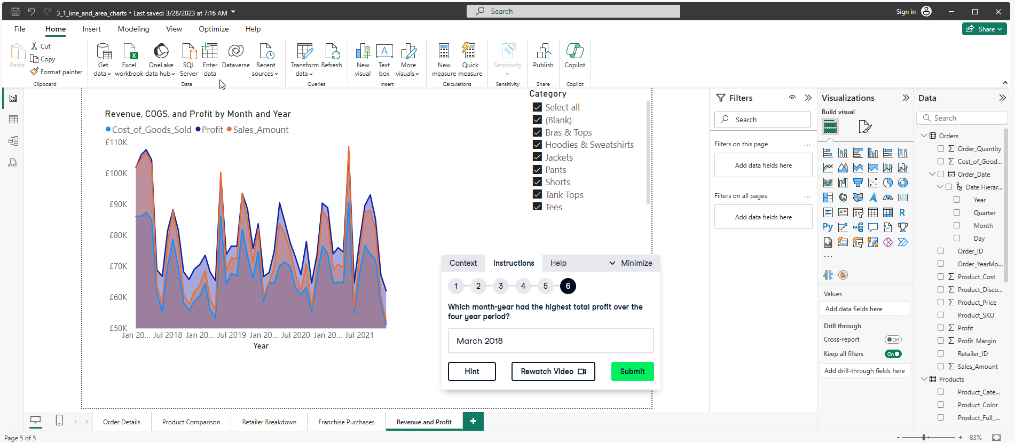

**Exercise 3.2**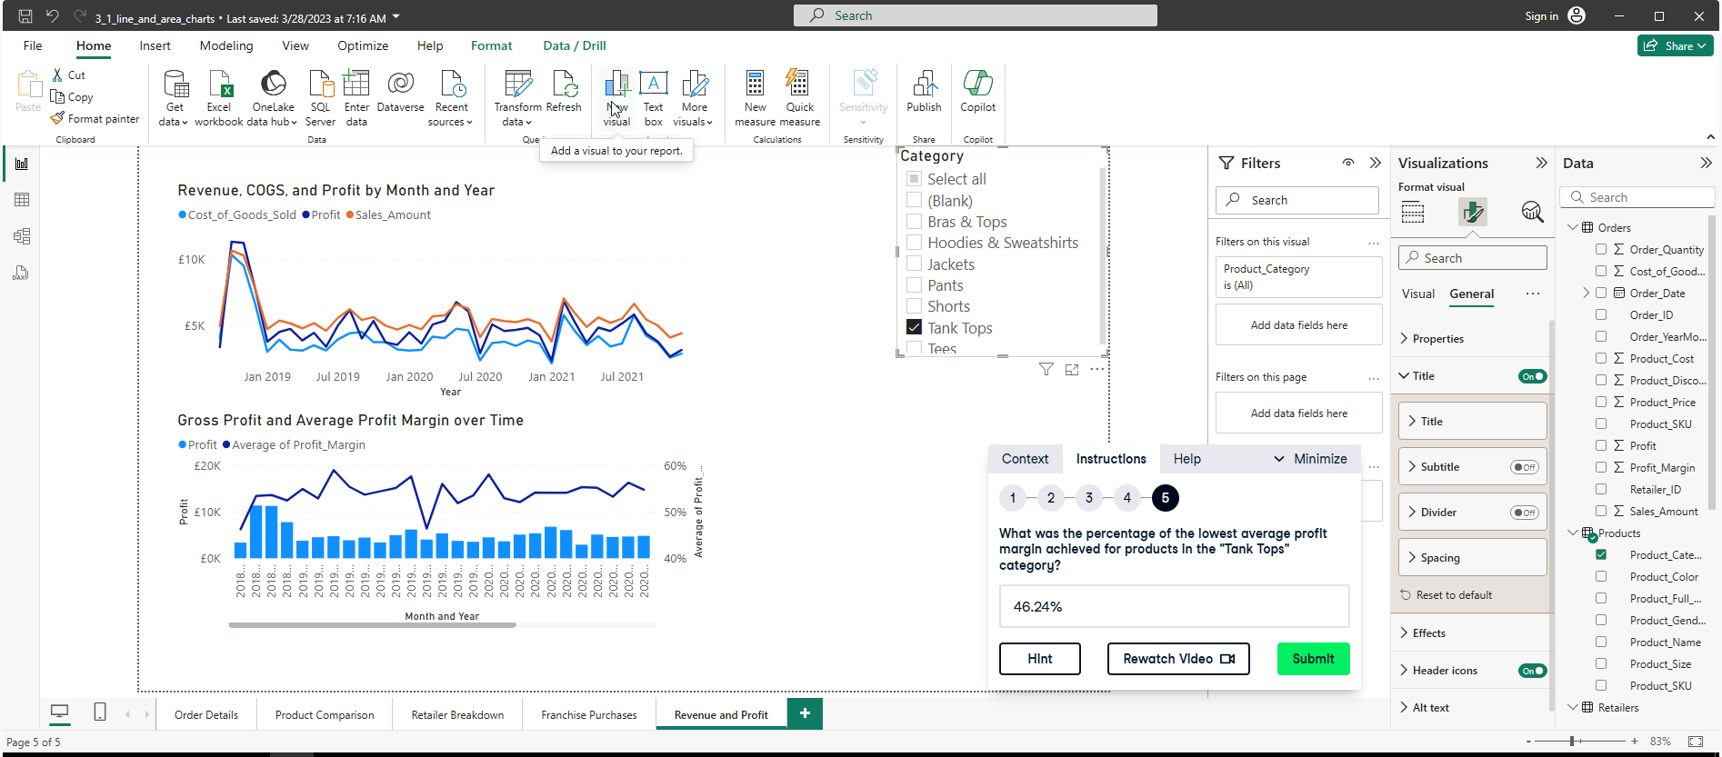

**Exercise 3.3**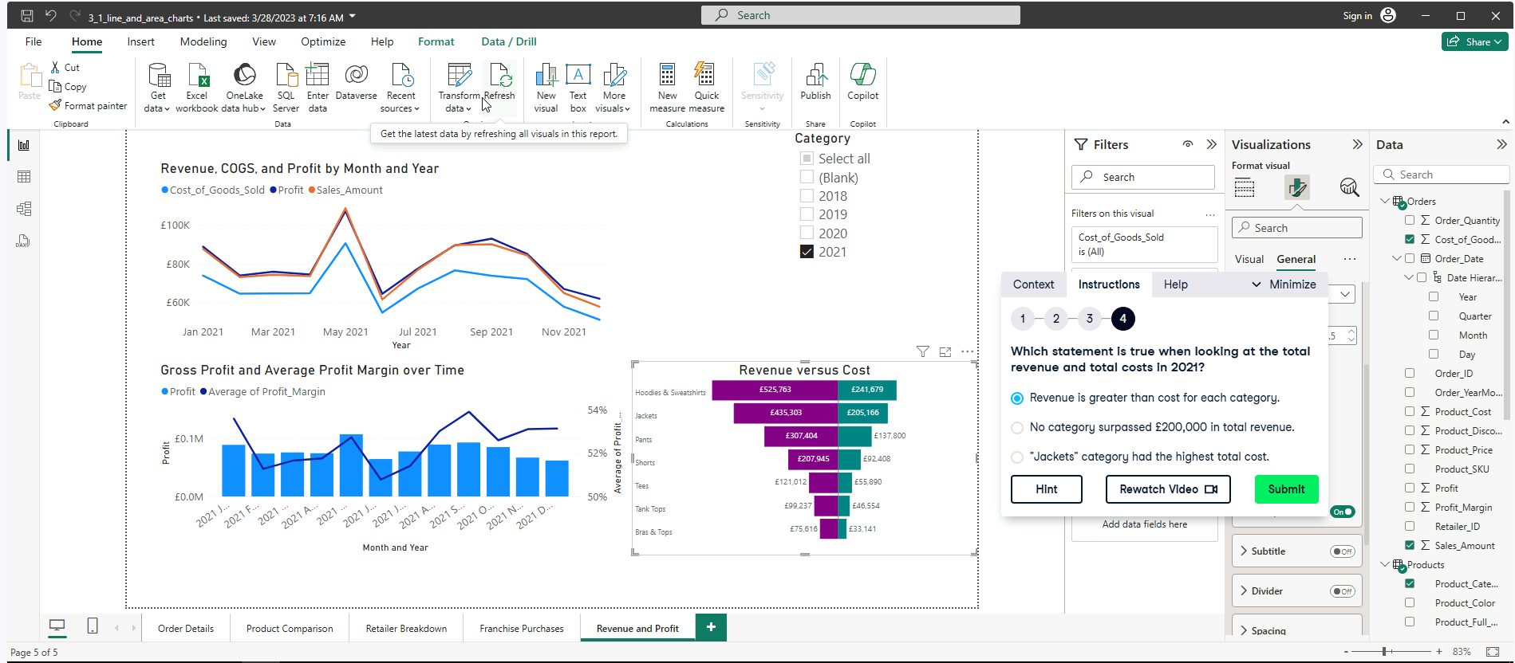

1. **Less is More**

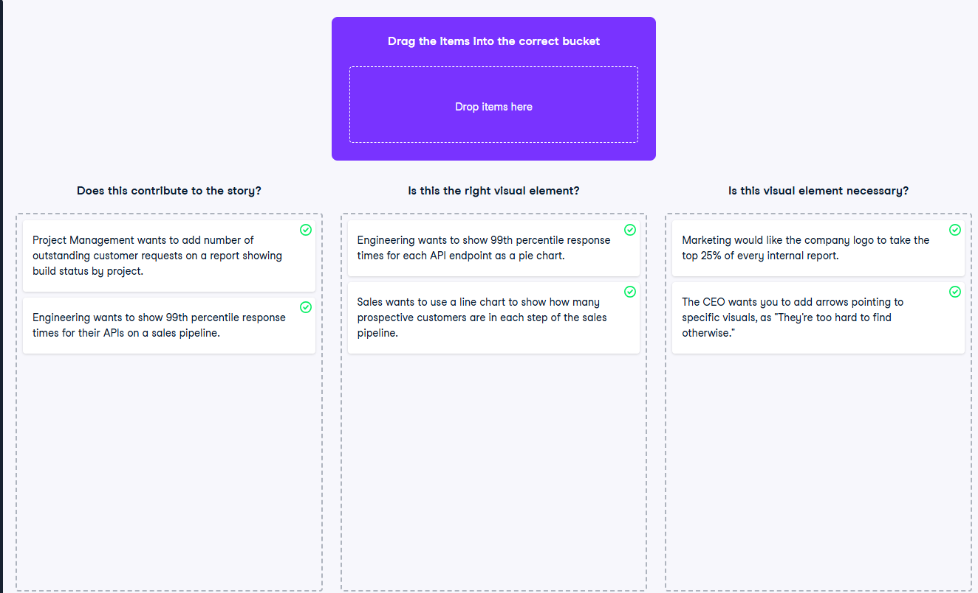

**Exercise 4.1**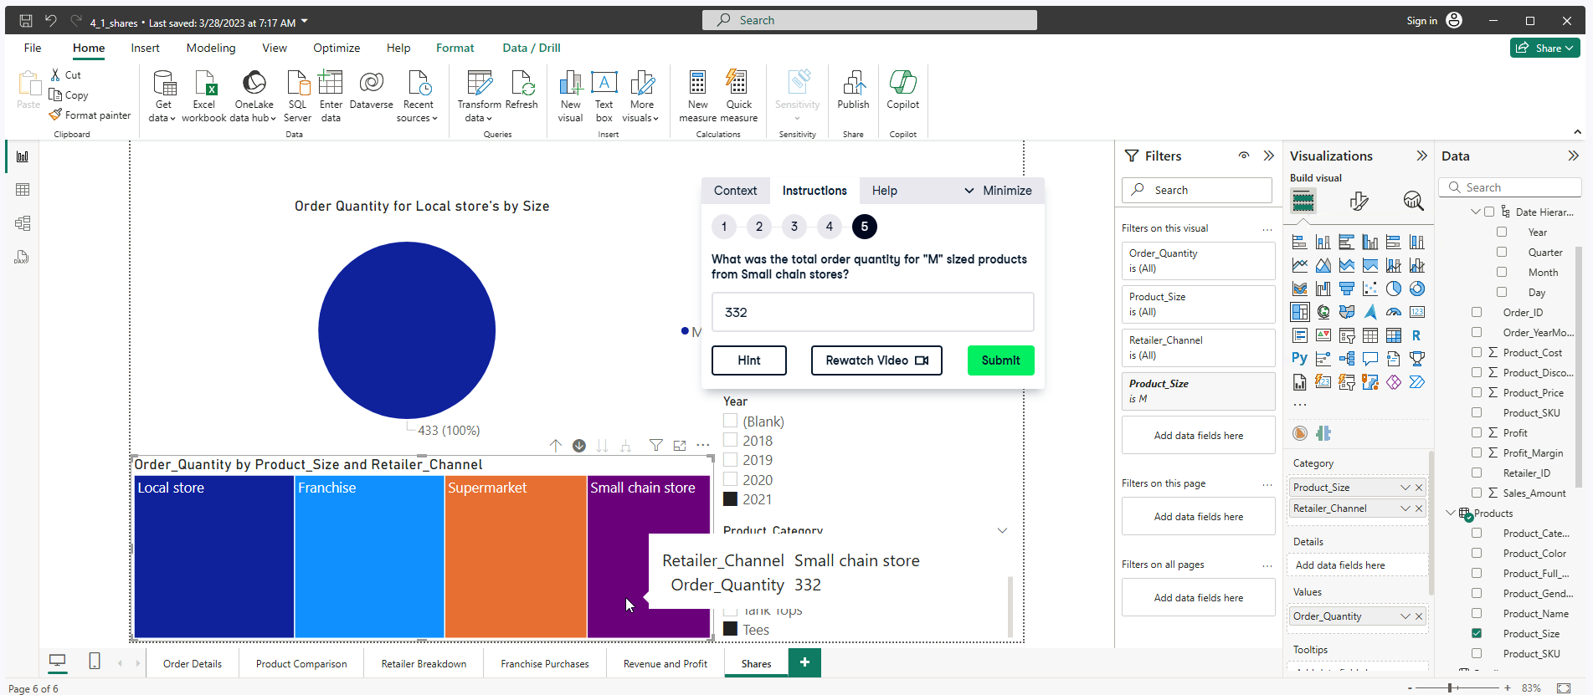

**Exercise 4.2**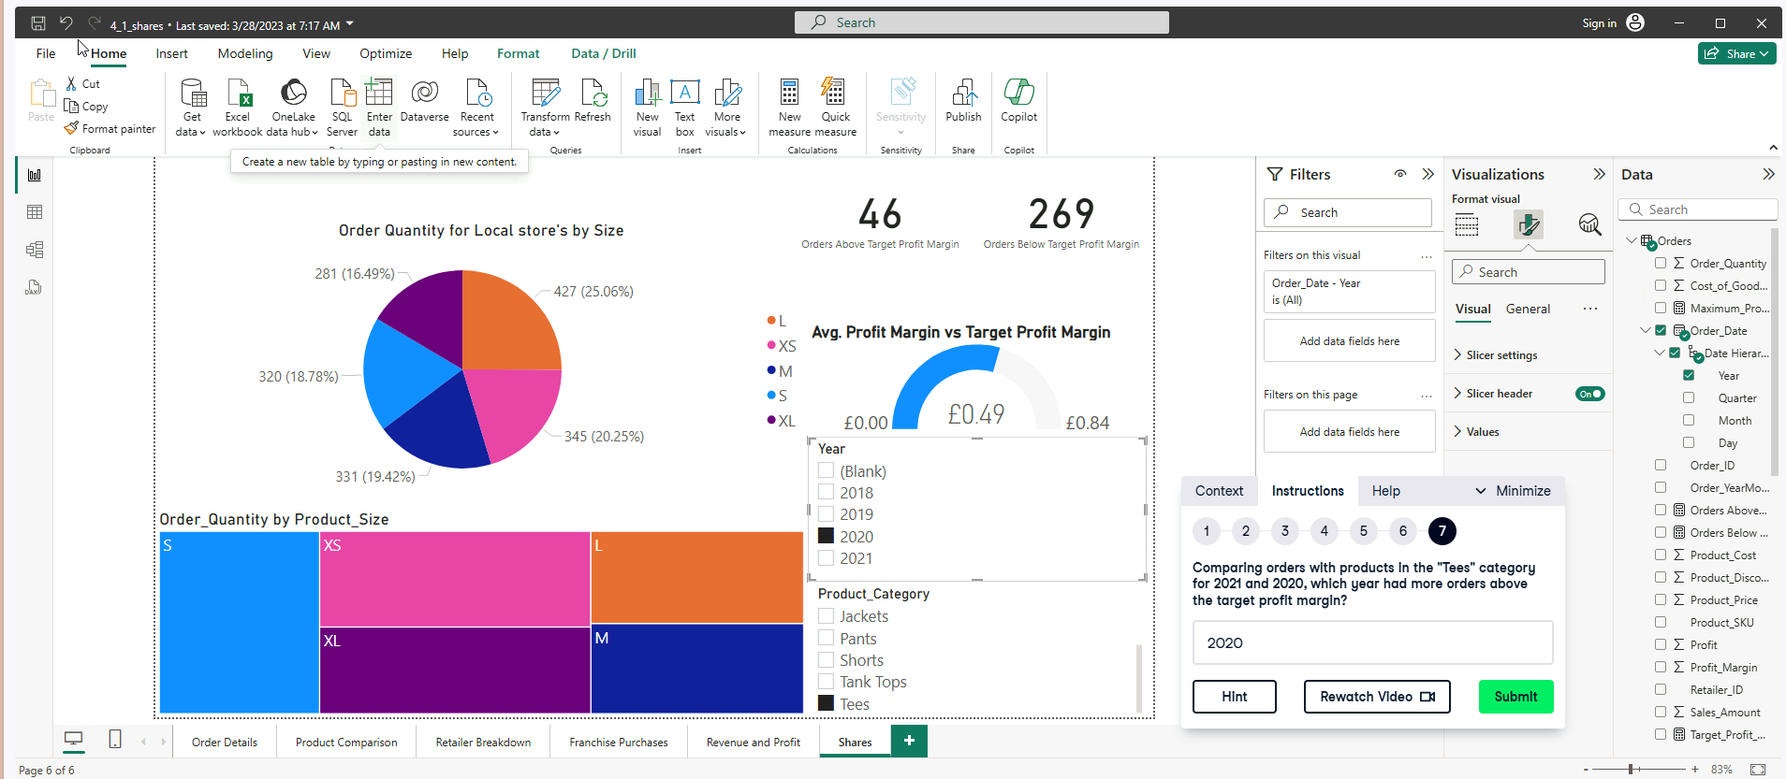

**Exercise 4.3**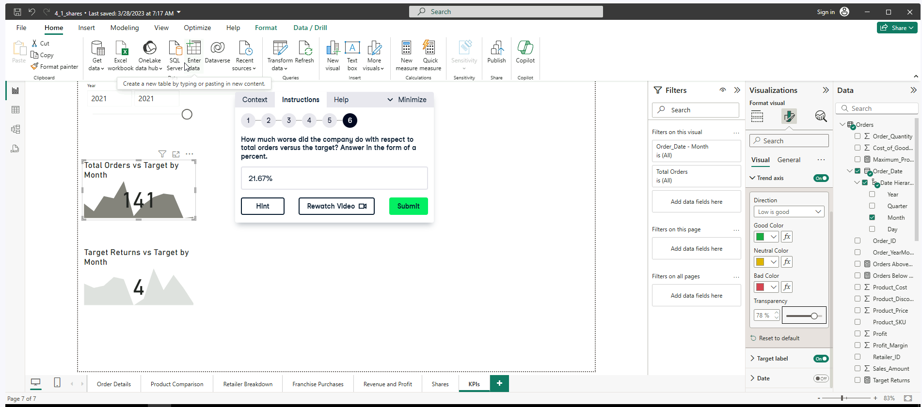

(180 – 141)/ 180 % = 21.67%

**With KPI enhancement**

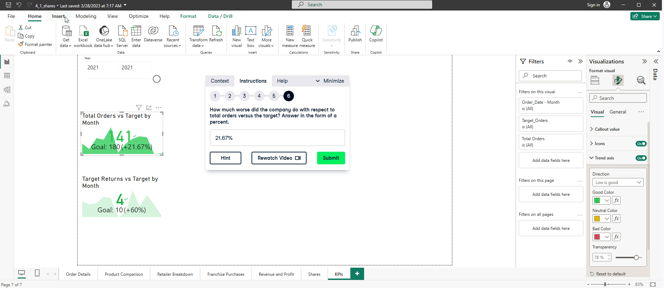

**With added new DAX measures as target labels**

* **Total Orders = 180**
* **Total Returns = 10**

